

Installation of the Adlib Internet Server
web application 3 (or the OAI server)

Adlib Information Systems

Copyright © 1992-2008 Adlib Information Systems B.V. ® All rights reserved. Adlib® is a product of Adlib Information Systems B.V. ® ®
The information in this document is subject to change without notice and should not be construed as a commitment by Adlib Information Systems. Adlib assumes no responsibility for any errors that may appear in this document. The software described in this document is furnished under a licence and may be used or copied only in accordance with the terms of such a licence. The software described in this document is furnished under a licence and may be used or copied only in accordance with the terms of such a licence.
Though we are making every effort to ensure the accuracy of this document, products are continually being improved. As a result, later versions of the products may vary from those described here. Under no circumstances may this document be regarded as a part of any contractual obligation to supply software, or as a definitive product description.
Contents
Introduction 1
1 Requirements 2
1.1 On the server computer 2
1.2 On a work station (client) 4
2 The installation procedure 5
2.1 Step 1: create a new sub folder 5
2.2 Step 2: create a virtual folder 5
2.3 Step 3: modify adlibweb.xml 11
2.4 Step 4: modify globalsettings.xml 11
2.5 Visiting the Internet Server web site locally 17
2.6 Testing the OAI Server 17
3 File types 18
4 Adlib OAI Server 21
4.1 Installing the OAI Server: global setup 22
5 Appendix: copyright notice for RTFX source code 25

Introduction
The Adlib wwwopac.exe implements the Adlib functionality for internet applications, and is installed as supplementary program to an existing web server (IIS 5.0 or higher for Windows 2000, XP, or higher).
But the program has no graphical interface, so therefore a web application is needed to address the wwwopac. Such a web application is a web site on which visitors can search your catalog via the internet, and maybe place reservations, or take care of other business.
For this, the standard Adlib Internet Server web application (which can largely be adjusted to your preferences) has been developed.
When installing the Adlib wwwopac.exe, you also install the Adlib Internet Server web application.
OAI functionality is part of Adlib wwwopac.exe but is also released as separate software, in the shape of Adlib oaiserver.exe. This OAI Server doesn’t need a web application (from your side). See chapter 3 in the WWWOPAC reference guide for more information about OAI. The OAI Server can be downloaded from the Adlib web site. In chapter 4 of the installation guide before you, you’ll find information about the composition and global setup of the OAI Server package.

Requirements
You will need the following programs to use the Adlib wwwopac.exe 4.7 or higher in combination with the Adlib Internet Server web application 3, or Adlib OAI Server:

On the server computer
- minimally Windows 2000 (Server or Professional edition), Windows XP (Professional edition), or Windows Server 2003. The Adlib Internet Server web application 3 does not function under Windows NT4, 95, 98, or ME.
For OAI Server, Adlib (adlwin.exe) version 5 or higher is required.
- an Adlib application (with a subfolder \data); although an application is not strictly necessary, just the \data folder is sufficient.
For OAI Server, for the \data subfolder at least read-only rights, and for the \oaicollectresult and \oaidocumentresult result folders write access rights, must be set for web users.
- the wwwopac executable or oaiserver executable, plus accompanying files delivered with the package, namely default.www (not for oaiserver) or adlibweb.xml, adlib.lic, adliblic.dll, adlibimg.dll (not for oaiserver), adlib.dll or adlibu.dll, adlibweb.dll (not for oaiserver), evalsmtp.dll (not for oaiserver), mfc71.dll, msvcp71.dll, msvcr71.dll, msvcrt.dll, and rtf2xml.dll. Put all dlls in the same virtual directory as oaiserver.exe or wwwopac.exe and your web application.
Optionally you can place the above mentioned files in the Windows \system32 folder too, instead of in the web application folder. Always, the \system32 folder is searched for said files first, and only when they are not present there the virtual directory from the search request is searched. But in \system32 the Adlib files cannot be kept up-to-date very comfortably.
- gdiplus.dll. The Microsoft file gdiplus.dll should be present on your system for the processing of images (not for oaiserver). For a Windows 2000 system those files should be in the WINNT\system32 folder; but, by default they aren’t, so you should try to obtain gdiplus through Microsoft’s site if the installation of (an upgrade of) wwwopac.exe didn’t automatically place this file there yet.
The gdiplus.dll file is present by default in Windows XP systems.
- http server software such as IIS from Windows 2000, XP, or 2003. IIS (version 5.0 or higher) must be installed on the server. This makes it possible for workstations (client side) to access pages from the server. For the required Windows versions, these services are available: already installed, or on the Windows installation cd’s.
IIS stands for Internet Information Services. Version 5.0 is the web service for Windows 2000 and Windows XP that lets you publish information on your Intranet or the Internet. To use Adlib’s webopac executable or oaiserver.exe, you must have a web server installed, preferably IIS.
A web server is a program that receives and handles web browser requests for web pages. The web server also starts additional programs and secures documents. The Adlib wwwopac or Adlib OAI Server is installed as an additional program with an existing web server.
All of Adlib Information Systems’ web applications use IIS and Active Server Pages. Other web servers with scripting support (e.g. Apache and PHP) can also be used, but in these cases customers themselves will have to provide the middleware scripts that are used in the so-called three-layer structure of Adlib Internet Server applications. AIS uses the Microsoft XML-parser (MSXML4) for processing XML. This software can be downloaded free from the Microsoft web site.
- MSXML4. Version 4.0 SP2 of the MSXML parser from Microsoft should be installed. You can check this in your registry (Start > Execute, type regedit and click OK). In it, search for the text MSXML. If the parser is not present, then you can download this software from the Microsoft web site (http://www.microsoft.com); from their homepage search for MSXML4. Open the relevant download page, choose the msxml.msi file to download and store it on your hard disk. Now install the software by double-clicking the file.
- The Microsoft .NET Framework version 1.1 must be installed on the server. See http://msdn2.microsoft.com/en-us/netframework/aa569264.aspx .
- minimally a workstation or server with at least a 450 MHz Intel Pentium 3 processor, and 192 MB of RAM or more.
- adserver.exe (not for oaiserver): the installation procedure has been designed for a workstation or server on which the Adlib program adserver.exe has not been installed yet. (Adserver is used for the Loans module.)

On a work station (client)
- a web browser such as Microsoft Internet Explorer or Mozilla Firefox. This lets you view web pages.
- a network connection to the server.

The installation procedure
As mentioned, MSXML4 and IIS have to be installed first.

Step 1: create a new sub folder
If the Adlib Internet Server web application or oaiserver.exe will be run on the same server as the “normal” Adlib modules, start by adding a new subfolder in the C:\inetpub\wwwroot folder (under Windows Vista) or for instance in the \Adlib Software folder (under Windows XP). (\Adlib Software or a folder with a similar name, contains your Adlib application and databases, as well as several other sub folders, depending on the type of your licence.) You can select a name for the new sub folder yourself, but we would recommend something like InternetServer or OAIserver.
You can now place all the files necessary for the Adlib Internet Server, or OAI Server, in this sub folder by copying and pasting all sub folders and files from the \web folder (for Internet Server) of the cd-rom released by Adlib, or (for OAI Server) by copying and pasting the unpacked folders Collect and Document. In Windows Explorer, then right-click the folder to which you have just copied all files, choose Properties in the pop-up menu and unmark the Read-only option. Click Apply and choose the Apply changes to this folder, subfolders and files option, in the window that appears, before clicking OK.
Note that it isn’t mandatory to place the new subfolder alongside the other Adlib folders. The Adlib Internet Server folder may even be located on a different server. In this case (when the web files are not on the same server as your \data folder), the \wwwopac subfolder (from underneath the InternetServer folder) must be moved to the database server. On this database server you also need IIS and MSXML4, so that the database can be approached over http.

Step 2: create a virtual folder
Besides a folder for all internet files, you need to make at least one new virtual folder in IIS, to secure your server and to create an Internet address.
- Open IIS by clicking Start > Settings > Control panel > Administrative tools > Internet Information Services.
- Now right-click Default WebSites in the left part of the window. In the shortcut menu that opens, select New > Virtual Directory (see image below). The Virtual Directory Creation Wizard opens.
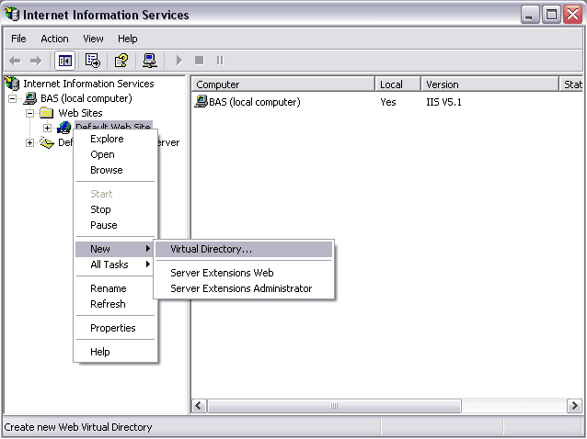

- Create a new virtual folder with the wizard. Choose a name for the virtual folder (AdlibWebApp, AdlibOAICollect or AdlibOAIDocument for example; for OAI Server each database configuration folder must get its own virtual folder!), and then browse to the real, physical folder on your system (for example the subfolder \InternetServer, \oaicollectconfig or \oaidocumentconfig).
- Finally in the wizard, you must specify the rights for this folder (see image below). For Internet Server you should check at least Read, Run scripts and Execute for the web application to work. For OAI Server that has to be minimally Read and Execute. If you want users of the Internet Server web application to be able to save for instance pointer files, also check the option Write. Complete the wizard.
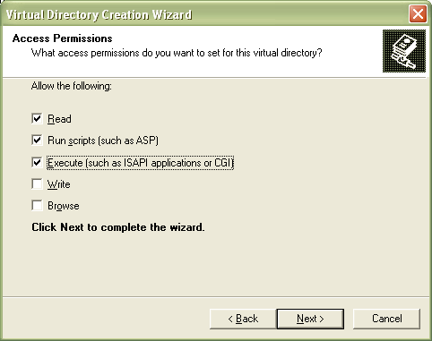

- Then, in the Internet Information Services window, open your virtual folder, e.g. AdlibWebApp, right-click the bin folder or the main folder and choose the option Properties. Set the execute permissions for this folder as in the image below. Note especially that Execute permissions has been set to Scripts and executables, and that the options The designated directory, Read, Log visits, and Index this resource (this one especially for MS indexing service, if you use that) have been marked. Click OK. (Ignore the presence of adlibIS in the example image.)
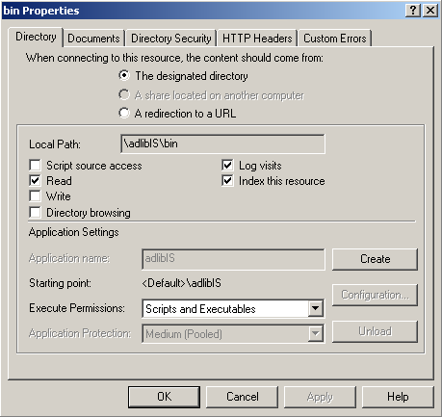

- For Internet Server, in the opened virtual folder AdlibWebApp, in the Internet Information Services window, right-click the xml folder and choose the option Properties. Make sure this folder and the files in it cannot be opened in the browser, by unchecking the Read option. Click OK.
- For Internet Server, in the opened virtual folder AdlibWebApp, in the Internet Information Services window, right-click the custom folder and again choose the option Properties. Here, uncheck the Read option too, to make sure this folder cannot be opened in a browser. Click OK.
- For Internet Server, only when adserver.exe has not been installed yet, then do that now as follows: in the Windows Explorer search the InternetServer\bin folder you just installed, and open it. Right-click the adserverInstall.bat file and choose Edit. Behind workdir, change the path to the wadcirc directory on your hard disk. Save the file and close it.
Then install adserver.exe by double-clicking the adserverInstall.bat file.

Extra settings for IIS 6 under Windows 2003
If your Internet Server web application runs under Windows Server 2003 with IIS 6, then the following settings are relevant:
- In the Internet Information Services Manager choose Web Service Extensions, select All Unknown CGI Extensions, and set the Status of it to Allowed: this is necessary to be able to run wwwopac.exe or oaiserver.exe.
Also set Active Server Pages to Allowed.
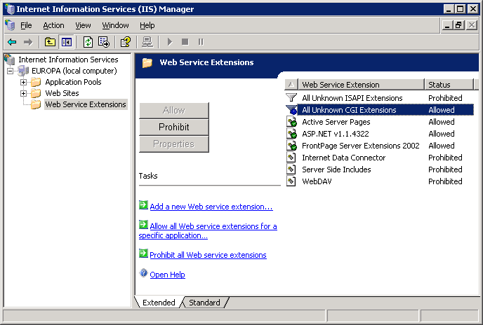

- Right-click Application Pools in the left pane, and choose New > Application Pool… in the pop-up menu. In the Add New Application Pool window, enter a name behind Application pool ID, for instance Adlib CGI. Mark the Use existing application pool as template option and select the DefaultAppPool in the Application pool name drop-down list.
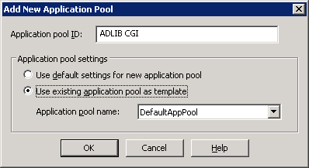
- Open the properties of the application pool you just made, by right-clicking it in the IIS Manager and choosing Properties.
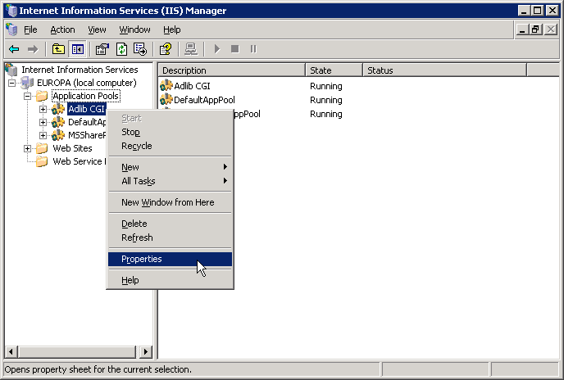
Open the Identity tab in the properties window. Choose the Predefined security account Local System. Local System has more rights than Network Service, and although this choice has proven to not always be necessary, it is recommended.
- Under Web Sites in the IIS Manager, select the virtual folder in which wwwopac.exe or oaiserver.exe runs. Right-click it and choose Properties in the pop-up menu.
Open the Home Directory tab in the window that opens and select the Application Pool you just created.
Click the Configuration… button on the same tab to open the Application Configuration window. Mark the Enable parent paths option on the Options tab. This last setting is necessary for the Internet Server and ASP, not for wwwopac.exe or oaiserver.exe.

Step 3: modify adlibweb.xml
The adlibweb.xml file serves to initialize the wwwopac executable or oaiserver.exe. In here you must at least enter a <databasepath> and a <database>. See chapter 1 in the WWWOPAC reference guide for more information about this (and possibly the chapters 3 and 4 for OAI, respectively SRU settings).

Step 4: modify globalsettings.xml
Contrary to adlibweb.xml, in which you provide wwwopac settings necessary for searching and for the search results to generate, in an XML document named globalsettings.xml in the custom\xml subfolder of your new InternetServer-directory you make general settings for the Internet Server web application.
The Internet Server web application (not for OAI Server) has to be told first which information comes from which virtual folders. That is why the path to wwwopac.exe must be set in globalsettings.xml.
Files with standard (Adlib) names in the subfolders of \custom have priority over files with the same name in other folders, and will not be replaced when an update of the web application is being made. So all files in which you make alterations, have to be copied first from the concerning InternetServer-subdirectory, to the proper InternetServer\Custom-subdirectory. One file has already been copied for you, so you can edit this directly: globalsettings.xml.

The path to the virtual folder in globalsettings.xml is specified in a code fragment that should look something like this:
<dataservers>
<server>
<url>
http://demo.adlibsoft.com/adlibIS3/bin/wwwopac.exe
</url>
<globalEmail>info@adlibsoft.com</globalEmail>
<smtpserver>smtp.adlibsoft.com</smtpserver>
</server>
</dataservers>

Behind <url>, enter the (http) URL to the webopac executable in the virtual folder on your system.
For the <globalEmail> you can enter your own “send from” address which is used when the web server sends an e-mail.
Most other settings in globalsettings.xml do not have to be changed if you installed your Adlib system by the defaults. Depending on the deviations in your installation, you do have to adjust the relevant settings. Below, you’ll find some more examples. Note that in globalsettings.xml itself most settings are clarified briefly, helping you to make correct adjustments.
Let’s view the <documents> group, for example:
<documents>
<file type="Reproduction/reproduction.identifier_URL">
<item>
<source>../images/</source>
<destination>../../database/images/</destination>
<downloaddestination>images/</downloaddestination>
</item>
<item>
<source>../test/</source>
<destination>images/</destination>
</item>
</file>
</documents>

Here, you can indicate per field which input strings must be replaced, for the Adlib Internet Server to correctly display images, external documents or for downloading zipped images and documents. This is necessary if the path which Internet Server uses is different from the entered path in your regular Adlib application. The “reformatted” value will be included as an attribute in the XML. This happens on-the-fly when retrieving the relevant file; no changes are made to the original data in the database.
In the example above, all entries of the reproduction.identifier_URL field with the value ../images/ or ../test/, get two extra attributes, namely weburl and downloadUrl. The weburl is a relative path to the image, with respect to the location of the Internet Server 3 web application. The downloadUrl is a relative path with respect to the location of the zip server. An example of the reproduction.identifier_URL node after the replace action, is the following:
<Reproduction>
<reproduction.identifier_URL
weburl="../../database/images/M53.jpg" downloadUrl=
"images/M53.jpg">
../images/M53.jpg
</reproduction.identifier_URL>
</Reproduction>

The <session> group contains settings which are set again per user session. In the example below you can see a selection of elements from this group. The elements themselves are subdivided into groups again, so that it’s easy to see which settings belong together:
<session>
<enableDownload>true</enableDownload>
<zipServerUrl>http://demo/getzip</zipServerUrl>
<recordgroupname>Groupname</recordgroupname>
<recordusername>Username</recordusername>

<type>advanced</type>
<database>ChoiceFullCatalogue</database>
<language>en</language>
<searchedfor>true</searchedfor>
<enableListPopUp>true</enableListPopUp>

<debug>0</debug>

<limit>50</limit>
<highlight>1</highlight>
<scanLimit>20</scanLimit>

<userdatabase>borrower</userdatabase>
<login>borrower_name</login>
<pass>borrower_number</pass>
<email>email_address</email>
<usergroup>test</usergroup>
<name>borrower_name</name>

<loan>true</loan>
<adserver_userid>gebruiker1</adserver_userid>
<adserver_password>pw1</adserver_password>
<adserver_location>centrale</adserver_location>
<loans_emailFrom>noreply@adlibsoft.com</loans_emailFrom>
<loans_emailTo>noreply@nl.adlibsoft.com</loans_emailTo>
<notification>false</notification>

<sdi>true</sdi>
<adapl>docfull</adapl>
<expiryInMonths>40</expiryInMonths>
<displaylist>
<dataset type="ChoiceFullCatalogue" presentationMemory="true">
<file selected="true" display="brief" label="CaptionBriefXSL">
briefLibrary.xsl</file>
<file selected="false" display="brief" label=
"CaptionCompactBriefXSL">compactBriefLibrary.xsl</file>
<file selected="true" display="detail" label="CaptionDetailXSL">
detailLibrary.xsl</file>
<file selected="false" display="detail" label="CaptionISBDXSL">
detailIsbd.xsl</file>
<file selected="false" display="detail" label="CaptionMARCXSL">
detailMARC.xsl</file>
<addToQuery />
<downloadfields>
<field>example_field</field>
<field>reproduction.identifier_URL</field>
</downloadfields>
</dataset>
</displaylist>

<globallogin>false</globallogin>
</session>

Explication of elements:
EnableDownload: switches the possibility for downloading on or off. Switching it on, means that on the Selection tab in the web application a button will appear for downloading images or zipped documents.
ZipServerUrl: this is the location of the virtual folder in which getzip.aspx runs.
Recordgroupname: this should contain the field name of the group name that is included in the catalogue record.
Recordusername: here you must enter the field name of the user name that is included in the catalogue record.
Type: determines whether the user starts with the simple or the advanced search form.
Database: this is the database name with which the web application starts. This has to be the same name as defined in the adlibweb.xml.
Language: With language you specify the language in which a user finds the web application at his or her first visit.
However, in the web application, the user is immediately offered the option to choose from other languages. Internet Server 3 by default offers: English (en), Dutch (nl), French (fr) and German (de).

An example of this setting for Dutch is:
<language>nl</language>
In the LanguageChooser.ascx user control you’ll find the language codes you can use. You may add new language options here, if you want (but only if you can offer all texts in the web application in that/those new language(s), of course).

(Often used abbreviations for languages are laid down in ISO-standard 639-2 and 639-1; see http://lcweb.loc.gov/standards/iso639-2/englangn.html).
Debug: enables (1) or disables (0) debug mode; the default is ‘off’. This can be set both through the form as in the web configuration file. Debug mode is useful in application development. This mode displays extra information about wwwopac, on the input variables and the search query composed by wwwopac. Moreover, a file named time_log.txt is created in your Internet Server bin folder, in which the duration (in seconds) of different parts of the execution of the aspx script will be logged. For this purpose, that execution is divided up in four parts: 1. initialisation (everything preceding sending the wwwopac urls); 2. http requests (from sending requests, up to and including receiving the xml – these durations are logged per server/url); 3. the undoubling/combining of all xml files; 4. further processing of the xml and displaying the html (finish).
Limit: this is the number of records that wwwopac retrieves at one time. This setting can be submitted through a CGI-string as well as through globalsettings.xml.
Maxlimit: sets a limit for the values that can be entered for limit. This variable can only be specified in globalsettings.xml and is meant to protect web servers against a DoS-attack. (Denial of Service by flooding a server with an overload of requests).
Highlight: switches the highlight function (in search results) of the Internet Server on (1) or off (0). If highlighting has been set in adlibweb.xml, you must also set it in globalsettings.xml to actually apply highlight layout in the web application user interface.
Scanlimit: this is the number of records that will be displayed if the user clicks a List button.
Userdatabase: the name of the database which holds user names and their login data.
Login, pass: the Adlib fields which are being used for authentication of user data during login.
Email: the field name in the users database, in which the e-mail address of the user can be found.
Usergroup: the field name of the user group in the users database.
Name: the field name in the users database, in which the name of the user can be found.
Loan: switches the possibilities for loan transactions on or off.
If you allow visitors to borrow items from your collection, then the program adserver.exe must be started for the loan. You need a user identification and a password for this. These are the same as the ones you use for the Loans transactions application. You can adjust the <adserver_userid> and <adserver_password> below to your own settings, if necessary.
SDI: switches the subscription service on or off.
Globallogin: all users first have to log in if this option is set to true. Only after logging in, pages can be requested in the Internet Server webapplication.
Displaylist: the next group consists of the <displaylist>. In here, the databases to be shown to the user are listed, the detail and brief presentation XSLT stylesheets to be used (to transform the XML search result from wwwopac to HTML) are selected, and any download fields are indicated.
Because multiple presentations are possible, multiple brief and detailed presentations can be included. With the attribute selected=”true” you specify which presentation will be offered first. For any one dataset only one brief display can be set to true and one detail. You can change these settings, and possibly adjust the stylesheets themselves as well.
Further it is possible to submit extra information per database:
- With <addToQuery> you can specify a part of the search statement that must always be added to queries for that database. This way you can shield certain content on field level.
- The <downloadfields> indicate which fields must be sent to the zip server. From within a selection of records, the referred files can then be downloaded by clicking the Download as zip button.

Visiting the Internet Server web site locally
- Start the browser from the station on which you installed the Adlib Internet Server, and enter the following URL: http://localhost/AdlibWebApp
The Adlib Internet Server web application 3 now opens.
* Instead of AdlibWebApp, fill in the name of your own virtual folder.
- You can also visit the web application from other desktops when your server has been set up in a network environment. Start the browser from a workstation that’s in the same network as the server on which you installed Adlib Internet Server. Enter the URL from the previous step again, but replace localhost by the name of the server in the network or the ip-address of the server, for example http://local_server/AdlibWebApp or http://192.168.0.3/AdlibWebApp. The Adlib Internet Server web application now opens.
* Instead of AdlibWebApp, fill in the name of your own virtual folder.

Testing the OAI Server
See chapter 3.6 in the WWWOPAC reference guide for information about this.

File types
Your sub folder for the Adlib Internet Server contains the following file types:
.asax
For each application there is one file with the .asax extension. This file is called global.asax and contains code that can be executed per application and per session. The global.asax file defines, amongst others, variables that are used in the application as a whole. It also loads static objects such as stylesheets, once only per application.
With the implementation of .NET, the source code is first compiled into a .dll, so global.asax itself does not contain code.
.aspx
These are .NET-specific files which look a lot like standard html files. In here you can specify the layout of the web application. A noticeable difference with html pages are the lines in between <% and %>. There you define which user controls you wish to use, and how the page should behave. Further you’ll find normal html tags, and user controls defined by AIS. The latter are similar to html tags, but their names have been specified by AIS.
web.config
This XML file is .NET-specific and contains configuration elements normally found in IIS, such as session time-outs, debugging, etc.
.css
A css (cascading style sheets) file determines the style of the elements (link, table, font, colour, background, margins, etc.) on a web page.
Anything in a css file can also be defined directly between the style tags in an HTML file. Preferably use a visual program for modifying a css file, such as Dreamweaver or Visual Studio.
.lic
You have an adlib.lic licence file, specific for your user agreement with Adlib. To be able to use the Adlib software, this file (or copies of it) and the accompanying adliblic.dll should be present in all directories in which Adlib .exe files occur, normally the bin or executables, tools and wwwopac subfolders of your (web) application.
wwwopac.exe
An exe file (executable) is an executable program. Wwwopac.exe is a CGI program (Common Gateway Interface). It serves as an intermediary between a workstation and the Adlib search engine. It translates search queries in the form of http commands (according to the CGI standard) into an Adlib search query, and executes them. Wwwopac.exe is the only executable that is necessary for Adlib Internet Server.
.xml
XML (Extensible Markup Language) is a standard with which data can be stored into a text file in a structured manner. Unlike an HTML document, an XML document provides information about the contents of the data, and not about its layout. So XML gives no information about presentation.
The sub folder \xml contains files with several settings for the web application. It can be used to determine the layout of forms, start-up settings and help texts.
Records that have been found with wwwopac are returned in XML. But the user on the internet will never see this XML, unless the web application is running in debug mode (then these XML files can be made visible).
The former www file is now called adlibweb.xml, and initialises the wwwopac executable. When a search is started, this web configuration file is read so the Adlib search engine can use the correct conditions for the search. The wwwopac program uses the commands in the web configuration file to obtain information on where it should search, and in what way the result should be presented to the web user.
The web configuration file may contain both complete paths and relative paths.
.xslt
The transformation of an XML file (e.g. to HTML or XML in another format) can be specified with XSLT (Extensible Stylesheet Language for Transformations).
XML documents can be transformed with XSLT into HMTL pages that can be viewed in a browser. This transformation can take place in two ways. The first way is by indicating in the XML file which XSLT file should be used for the transformation. When this file is retrieved in a browser (that supports XML transformation), the transformed document will be presented. This is called client-side transformation. We do not use this type in our Adlib web applications, because it makes users dependent on a type of browser that supports XML, and not very many users have those yet.
The second way circumvents this problem and is called server-side transformation. The transformation now takes place on the web server, so only the server needs to support XML. The transformed document can now be sent to the user. This way also allows for multiple small pieces of transformed XML to be used on the same page.
The subfolder \xsl contains files that determine the layout of forms and records. (Together with the css styles, all of the graphic design is determined.)

Adlib OAI Server
The OAI-protocol, based on HTTP and XML, is a metadata harvesting protocol, intended to make the normally invisible contents of internet databases accessible and searchable by search engines through a submitted term. In other words: if you would like to make one or more of your Adlib databases searchable and indexable for internet search engines, then OAI is an interesting protocol for this purpose. (Fore more information, see chapter 3 in the WWWOPAC reference guide.)
Until early 2005, you had to buy a license for Adlib Internet Server, to be able to use the OAI-protocol for your Adlib system: this is because the Adlib OAI server is a part of wwwopac.exe. But since AIS would like to stimulate the use of OAI, there is also a separate Adlib OAI Server available (oaiserver.exe), and it is completely free of charge for Adlib customers; a license for the Internet Server is no longer necessary. We have put together an surveyable and relatively easy to install package, in which most settings are ready-to-use (although you are welcome to edit them). Aside from executable files, in this package you’ll namely find two largely set configuration files for the COLLECT and DOCUMENT database (according to Museum Plus 2.1.2 up to and including 3.6), and in their own folder two accompanying xslt stylesheets with a mapping of about fifteen Adlib fields to Dublin Core elements (see http://www.cimi.org/). So you don’t have to make all this yourself. Little stands in your way anymore to start using OAI!
For a list of system requirements, see chapter 1 in this installation guide.
If you already have an Internet Server web application, and you wish to put OAI into service, then in principle you don’t need oaiserver.exe because OAI support is already built into wwwopac. However, you can copy the \oaidocumentresult and \oaicollectresult folders from the OAI package and paste them next to your Internet Server \bin folder, and copy the <oaiconfiguration> section from the accompanying adlibweb.xml file and paste it in your own adlibweb.xml file for Internet Server, to be able to have a quick start.
On the other hand, for an official validation of your new OAI repository (see chapter 3 in the WWWOPAC reference guide) it is necessary to use oaiserver.exe. This is because for wwwopac it is not always clear in what context it is being called. The error handling of oaiserver.exe completely meets the requirements of the OAI protocol and allows validation. If validation is desired – this is necessary to be able to register your repository with certain search engines – then follow the installation procedure below.

Installing the OAI Server: global setup
- Go to the download page on our web site, to get the OAI package, if you haven’t done that already, or request it through our helpdesk if the package is not being offered as a download.
- E-mail our helpdesk with your organisation’s details, for the password that is necessary to unpack the .zip file.
- The Adlib OAI Server must be installed as supplementary program to an existing web server (IIS 5.0 or higher for Windows 2000, XP, or higher). No web application is needed to address the OAI Server. Now, place the unpacked OAI package and configure IIS according to chapter 2.1 and 2.2 in this installation guide.
Note that you’ll find two folders in the main folder of the OAI package: Collect and Document, that in turn are divided into a configuration and result folder. Leave this division intact. Although you only need one \data folder, you’ll have to have a separate folder for each database that you want to make available for OAI harvesting, in which the executable server files and the settings files are located.
- Copy your adlib.lic license file to the subfolders \oaicollectconfig and \oaidocumentconfig.
- There are two prepared OAI configurations, one for the DOCUMENT and one for COLLECT database, each in its own folder. Depending on which databases you have, and wan to make available for OAI harvesting, you can put one of them or both into action.
So you’ll find two folders in the main folder of the OAI package: Collect and Document, that in turn are divided into a configuration and result folder. Leave this division intact. Although you only need one \data folder, you’ll have to have a separate folder for each database that you want to make available for OAI harvesting, in which the executable server files and the settings files are located.
In the adlibweb.xml configuration file of each database that you want to make available, you must make some adjustments (open them in a text editor):
- Dependent on where your \data subfolder is located with respect to oaiserver.exe, you’ll have to change the relative path in <databasepath>..\data</databasepath> to the actual situation. This could be ..\..\data for instance, if the \data subfolder is located at a level higher. It may also be an absolute path to a drive or a UNC path.
- You must fill in <OAI_REPOSITORY_NAME>, <OAI_DIR> and <OAI_ADMIN_EMAIL> yourself. (See chapter 3 in the WWWOPAC reference guide for an explanation of these settings.)
- Optionally, also the following settings may be adjusted, but in principle you don’t need to: <OAI_REPOSITORY_IDENTIFIER>, <OAI_MAX_RECORDS>.
Note that you may adjust the mapping in the xslt file (for instance because the field names in your application are different), and that you may also make other databases available, by copying the Collect folder for example, and renaming it to the other database, and then by editing the concerning adlibweb.xml and oai_dc.xsl file and also applying the rest of the installation procedure to this new folder.

Appendix: copyright notice for RTFX source code
(This souce code is used by Adlib in rtf2xml.dll.)

Copyright (c) 2004, Nate Nielsen
All rights reserved.

Redistribution and use in source and binary forms, with or without modification, are permitted provided that the following conditions are met:
- Redistributions of source code must retain the above copyright notice, this list of conditions and the following disclaimer.
- Redistributions in binary form must reproduce the above copyright notice, this list of conditions and the following disclaimer in the documentation and/or other materials provided with the distribution.
- The names of contributors to this software may not be used to endorse or promote products derived from this software without specific prior written permission.

THIS SOFTWARE IS PROVIDED BY THE COPYRIGHT HOLDERS AND CONTRIBUTORS "AS IS" AND ANY EXPRESS OR IMPLIED WARRANTIES, INCLUDING, BUT NOT LIMITED TO, THE IMPLIED WARRANTIES OF MERCHANTABILITY AND FITNESS FOR A PARTICULAR PURPOSE ARE DISCLAIMED. IN NO EVENT SHALL THE COPYRIGHT OWNER OR CONTRIBUTORS BE LIABLE FOR ANY DIRECT, INDIRECT, INCIDENTAL, SPECIAL, EXEMPLARY, OR CONSEQUENTIAL DAMAGES (INCLUDING, BUT NOT LIMITED TO, PROCUREMENT OF SUBSTITUTE GOODS OR SERVICES; LOSS OF USE, DATA, OR PROFITS; OR BUSINESS INTERRUPTION) HOWEVER CAUSED AND ON ANY THEORY OF LIABILITY, WHETHER IN CONTRACT, STRICT LIABILITY, OR TORT (INCLUDING NEGLIGENCE OR OTHERWISE) ARISING IN ANY WAY OUT OF THE USE OF THIS SOFTWARE, EVEN IF ADVISED OF THE POSSIBILITY OF SUCH DAMAGE.

CONTRIBUTORS
Nate Nielsen nielsen@memberwebs.com
http://memberwebs.com/nielsen/software/rtfx/

